Training for WARUNG NAIK KELAS AND Signing of UMA MoU with Bukalapak
Medan Area University were a Training in Warung Naik Kelas by Bukalapak and at the same time the signing of an MoU with Bukalapak Gelanggang Campus I of the Medan Area University on Tuesday, January 8, 2019 at Campus I, Universitas Medan Area Jl. Kolam No. 1 Medan Estate.
The activity was attended and opened by the Rector of the University of Medan Area Prof. Dr. Dadan Ramdan, M. Eng, M.Sc as well as the signing of the MoU with Bukalapak, Vice Chancellor for Student Affairs H. Muzzul, SH, M.Hum, Chairperson of UMA PKK Ahmad Prayudi, SE, MM, UMA Public Relations Ir. Asmah Indrawati, MP, the training participants who attended, and also attended the Bukalapak Team
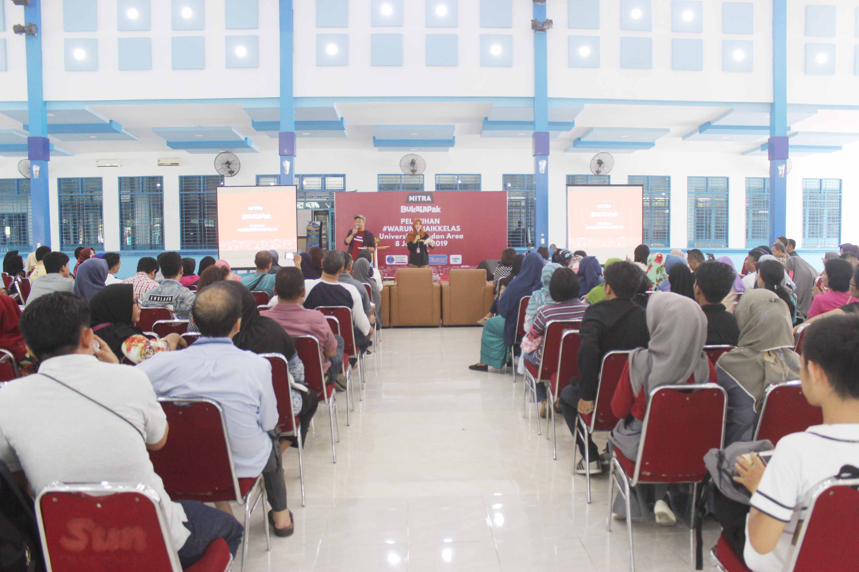
#Warungnaikkelas is a forum given by Bukalapak through activities organized by UMA to Bukalapak agents and partners to establish a modern warung.

